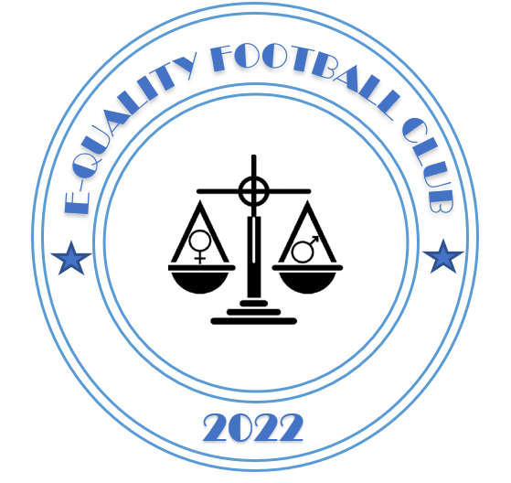

E-quality Football Club

PARENTS CODE OF CONDUCT 2022/2023

Dear Parent,
We all have a responsibility to promote high standards of behaviour in the game and allow out kids to play football in a positive environment.
We support the FA’s Respect programme which serves to ensure football can be enjoyed in a safe, positive environment.
Remember children’s football is a time for them to develop their technical, physical, tactical and social skills. Winning is only a small part of the process for ensuring kids develop in the beautiful game.
Please play your part and observe The FA’s Respect Code of Conduct for spectators and parents/carers at all times:-
• Remember that children play for FUN and to be with their mates
• Applaud effort and good play, as well as success
• Even when you think the officials are wrong at the end of the day the Officials decision is final, always respect the match officials’ decisions (at the end of the day you can’t change their decision)
• Remain outside the field of play and within the Designated Spectators’ Area (if provided)
• Let the coach do their job and don’t confuse players by also coaching them
• Encourage the players to respect the opposition, referee and match officials
• Avoid criticising a player for making a mistake – mistakes are part of learning
• Never engage in offensive, insulting, bullying or abusive language or behaviour. This includes at match days, at training sessions, and at any other Club event, meeting or gathering.
• Never use personal social media accounts to convey feelings about any player, parent, coach or official of E-quality FC or any other junior football club, that may be construed as insulting or offensive.
Please understand that if a parent does not follow the Code, any or all of the following actions may be taken by the Club, Durham County FA, The Russell Foster Youth League or The FA:-
• You may be issued with a verbal warning from a club or league official
• You may be required to meet with the club, league or County FA Welfare Officer
• You may be required to meet with the club committee
• You may be obliged to undertake an FA education course
• You may be obliged to leave the match venue by the club
• You may be requested by the club not to attend future games
• You may be suspended or have your club membership removed
• You may be required to leave the club along with any dependents
• The FA/County FA may impose a fine and/or suspension on the club

I, ______________________________ parent of ______________________________ have read and understand the E-quality FC Code of Conduct for 2022/2023 Signed ____________________________________ Date ______________________

