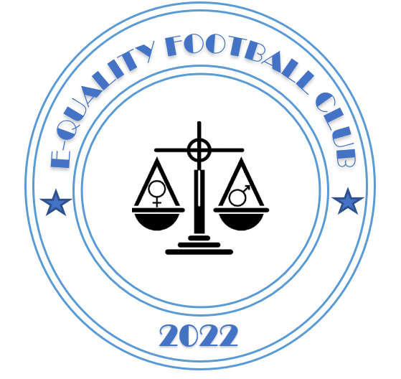
The FA Charter Standard Club Programme Club Complaints Procedure

Club Complaints Procedure
In the event that any member feels that he or she has suffered discrimination in any way or that the Club Policies, Rules or Code of Conduct have been broken, they should follow the procedures below:
1 They should report the matter to the Club Secretary or another member of the Committee. The report should include:
- Details of what, when and where the occurrence took place
- Any witness statement and names
- Names of any others who have been treated in a similar way
- Details of any former complaints made about the incident, date, when and to whom made
- A preference for a solution to the incident.
2 The Club’s Management Committee will sit for any hearings that are requested.
3 The Club’s Management Committee will have the power to:
- Warn as to future conduct
- Suspend from membership
- Remove from membership any person found to have broken the Club’s Policies or Codes of Conduct.
Addendum to the Complaints Procedure;
E-quality Football Club - Complaints Procedure and Grievance Policy
It is recognised that in any football club, differences and misunderstandings may arise. Successful resolution of differences depends on the willingness of the parties involved to communicate with one another. Every effort should be made to resolve disputes in an informal manner whatever issues arise. However, there will be occasions where issues cannot be resolved informally. It is the policy of E-quality Football Club to provide an orderly and formal procedure to deal promptly and fairly with any serious differences of opinion.
Informal Procedure
• Discuss the complaint with the aggravator and seek a resolution as soon as practical.
• Talk directly face to face.
• Avoid emails
• Where no satisfactory solution is possible, initiate a formal Grievance procedure.
Formal Grievance Procedure
As soon as practical issue a description of the complaint in writing to the E-quality Football Club Chairman in accordance with the FA Charter Standard Club Programme Complaints Procedure.
• The grievance must state the alleged issue, and in your view a suggested resolution to the grievance.
• A Grievance Panel will be formed consisting of three members of the E-quality FC Club Committee.
• The Grievance Panel will formally respond to the grievance and if necessary request further information.
• A Grievance hearing involving all interested parties will be called, where all sides can put their case forward.
• Having heard all sides of the argument, the Grievance Panel will make a decision on how best to resolve the complaint. This decision will be communicated to all interested parties.
• Decisions on all grievances will be made within two weeks of the formal procedure being initiated.
• The decision of the Grievance Panel is binding and no appeal is allowed.

