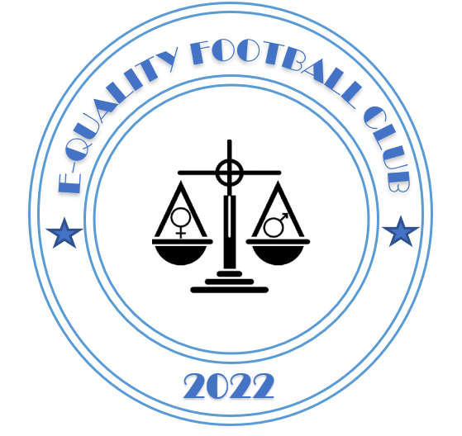

E-quality Football Club

COACHES CODE OF CONDUCT 2022/2023

Dear Coach,
We all have a responsibility to promote high standards of behaviour in the game and allow out kids to play football in a positive environment.
We support the FA’s Respect programme which serves to ensure football can be enjoyed in a safe, positive environment.
Remember children’s football is a time for them to develop their technical, physical, tactical and social skills. Winning is only a small part of the process for ensuring kids develop in the beautiful game.
Please play your part and observe The FA’s Respect Code of Conduct for Coaches at all times:-
On and off the field, I will:
• Always show respect to everyone involved in the game
• Stick to the rules and celebrate the spirit of the game
• Encourage fair play and high standards of behaviour
• Always respect the Referee and encourage players to do the same
• Never enter the field of play without the Referee’s permission
• Never engage in, or tolerate offensive, insulting or abusive behaviour
• Be aware of the potential impact of bad language on others
• Be gracious in victory and defeat
• Respect the facilities home and away

When working with players, I will:
• Place the well-being, safety and enjoyment of each player above everything
• Never tolerate any form of bullying
• Ensure all activities are suited for the players’ ability and age
• Work with others (e.g. officials, doctors, welfare officers, physiotherapists) for each player’s best interests
• I will make myself familiar with safeguarding practices & review guidance on physical contact (5.6) & Acceptable Behaviours When Working With Young People (5.7) documents on the safeguarding section of EnglandFootball.com

I understand that if I do not follow the Code, I may be:
• Required to meet with the club committee, league or CFA Welfare Officer
• Suspended by the club from attending matches
• Suspended or fined by the County FA
• Required to leave, lose my position and/or have my license withdraw

I, ______________________________ Coach of ______________________________ have read and understand the E-quality FC Code of Conduct for 2022/2023 Signed ____________________________________ Date ______________________

