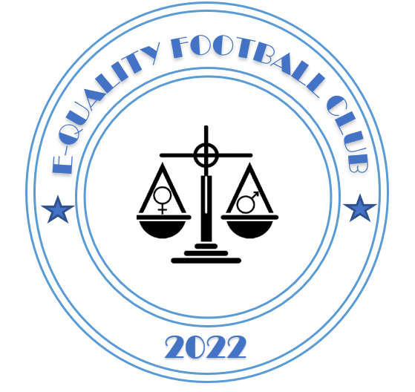

E-quality Football Club
PLAYERS CODE OF CONDUCT 2022/2023

Dear Parent / Player,
We all have a responsibility to promote high standards of behaviour in the game and allow out kids to play football in a positive environment.
We support the FA’s Respect programme which serves to ensure football can be enjoyed in a safe, positive environment.
Please play your part and ensure team individuals / players follow the following requirements at all times:-
Players As a player for E-quality Football Club I will:
- Wear the match day clothing given to you at the beginning of the season by E-quality Football Club.
- On arrival shirts should be tucked in, socks pulled up, shins must be worn, no jewellery and hair to be tied back
- Always do my best, even if the team is losing
- Play fairly at all times, I will not cheat.
- Respect the referee decision is final and I will not complain
- Respect my fellow team mates, opposition team, referee, spectators and my coach
- At the end of the match, shake hands with the opponents by lining up, whatever the result
- Play safely, remembering it is only a game, and should be enjoyed

I understand if I do not follow the code any/ all of the following actions may be taken by my Club, County FA or The FA
- Be required to apologise to my team mates, the other team, referee of coach
- Receive a formal warning from the coach or the Club Committee
- Be dropped or substituted
- Be suspended from training
- Be required to leave the Club

I understand the code above and have to signed show that it will be followed Signed: ............................................................................ (child) Date: ...................................
Print: ............................................................................ (child’s Parent signature)

